NEXTHIKES IT SOLUTIONS

BIKE SHARING DEMAND ANALYSIS PROJECT USING EXCEL



We have been given 3 datasheets based on the data provided for demand of bike sharing observed on particularly the month of January and February.

I have done the processes written below to analyse the data to get a clear view on the bike renting/sharing based on time(hour),season,weather,temperature etc.

1.First I have filtered the data and checked every column every datasheet whether there is any duplicate value or not.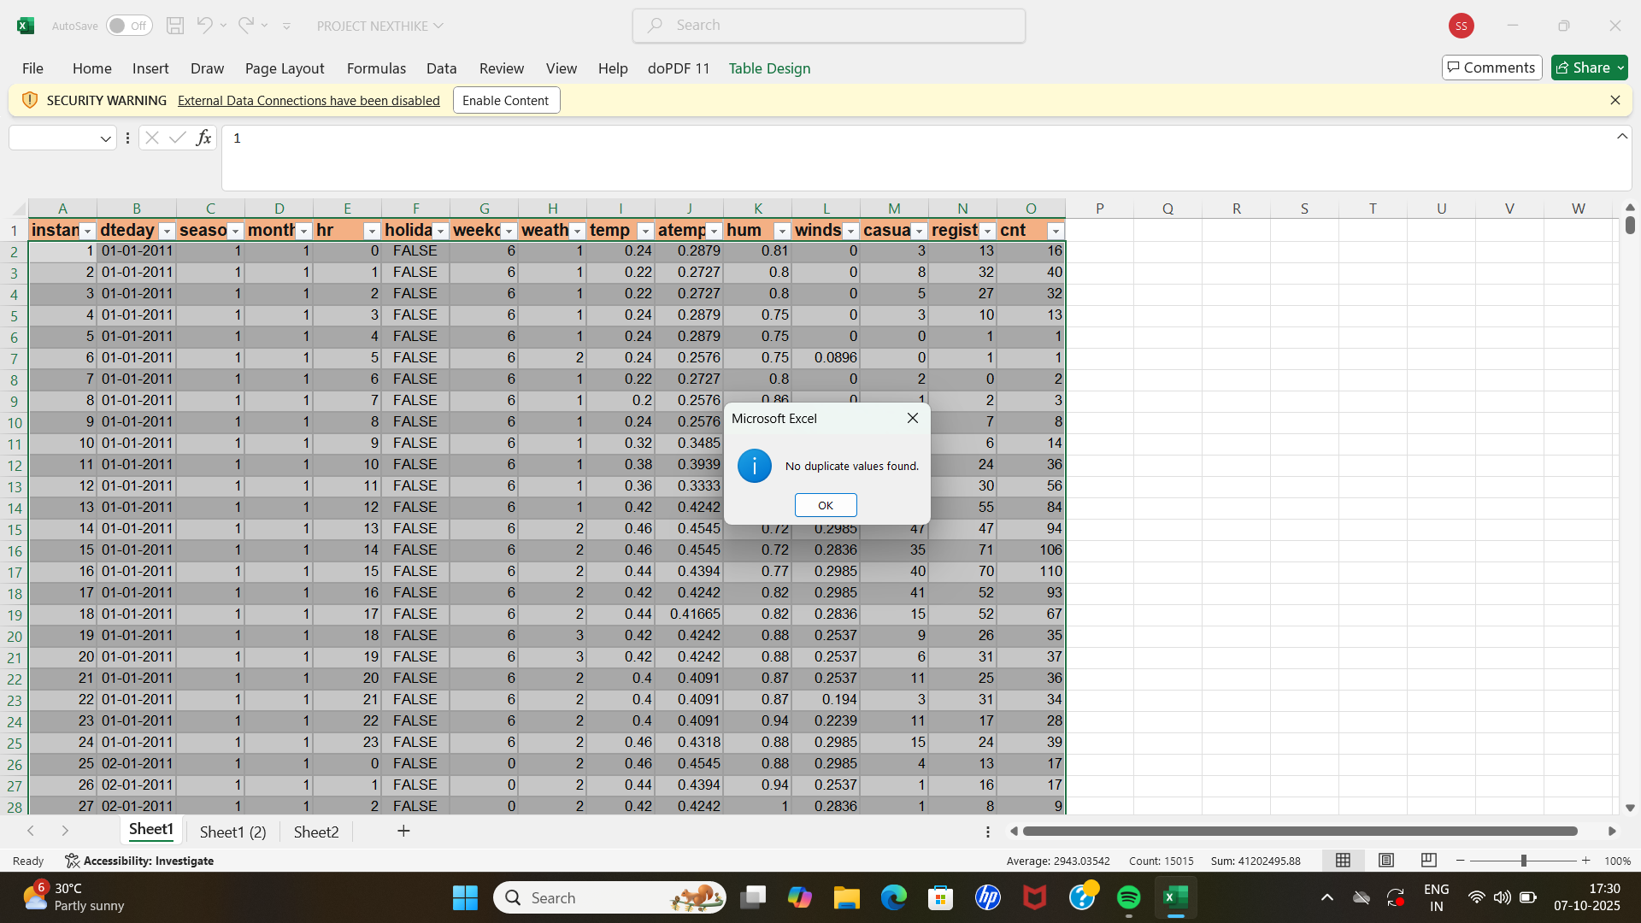

**Then I have checked for the missing values and for those filled it up with average data. The atemp column had some blank cell which I filled with the average value.**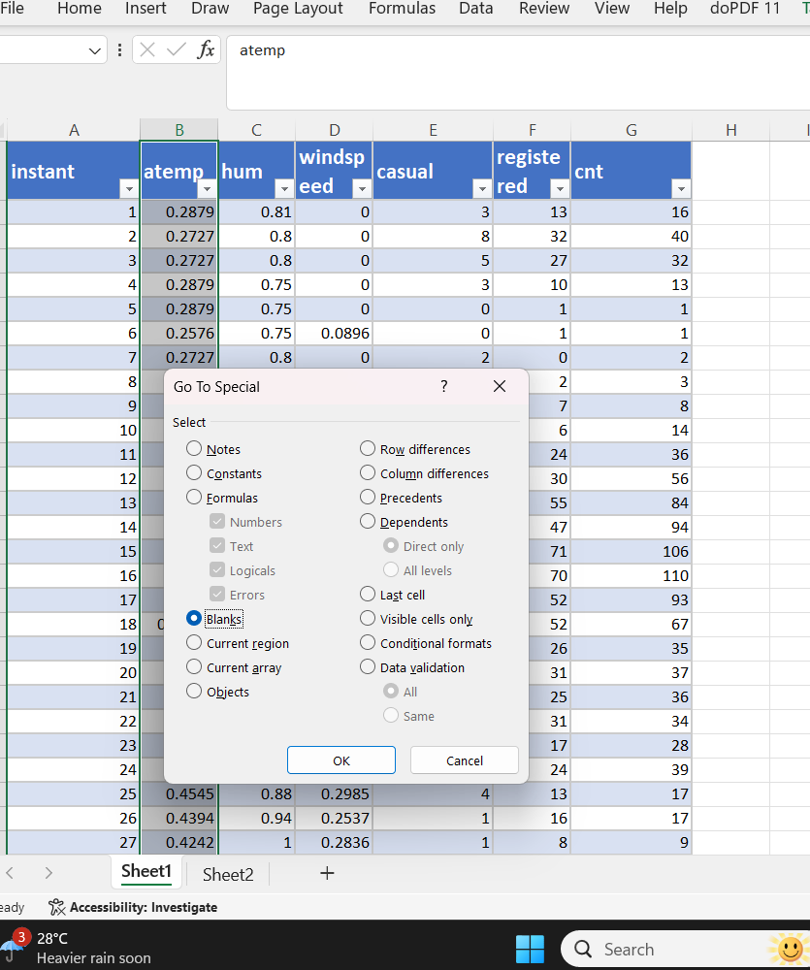

**2.After completing all the preprocessing on individual datasheets I have merged all the sheets one by one,1st,sheet 1 and 2 then sheet 3 with the previously merged sheet.**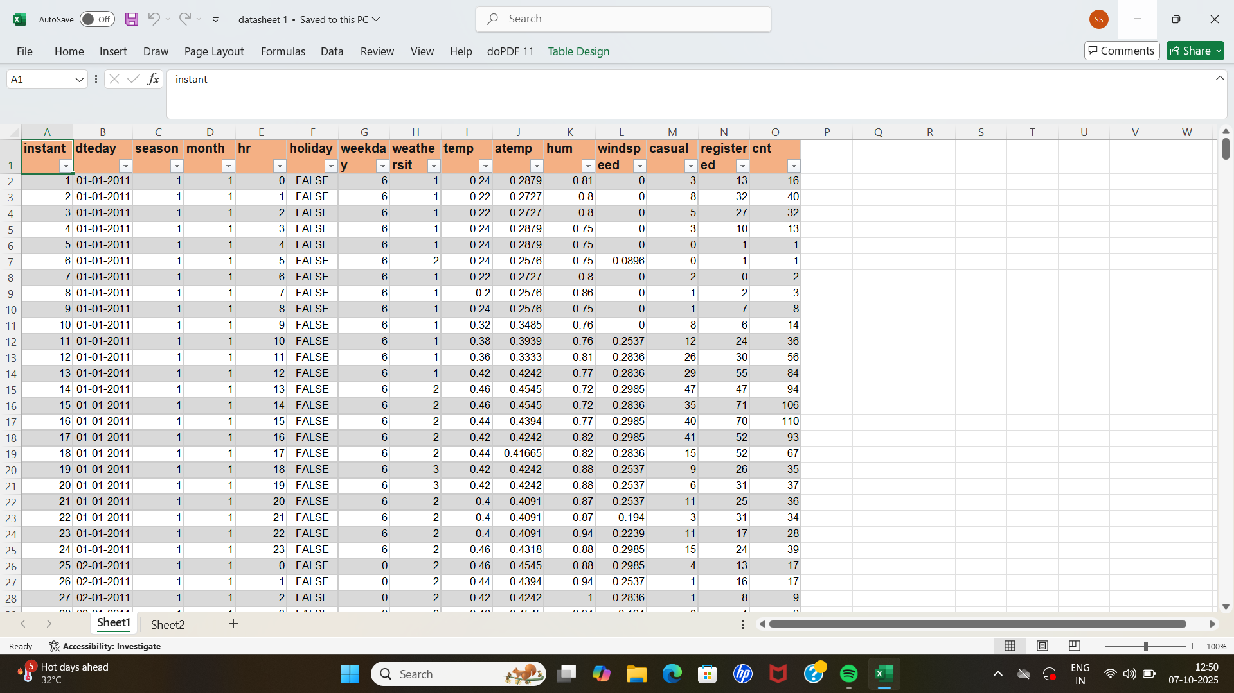

**3.Then on the final datasheet I have performed under written function:**

**i.Text function on date to visualize the data easily,**

**ii.IF function to get clarification on weather precisely on humidity and on day(weekend vs weekday),**

**4. To get the report summary or analyse the data I did**

**i.sum of total customer**

**ii.average temperature through out the survey**

**iii.get the correlation value for temperature with total count of customer.**

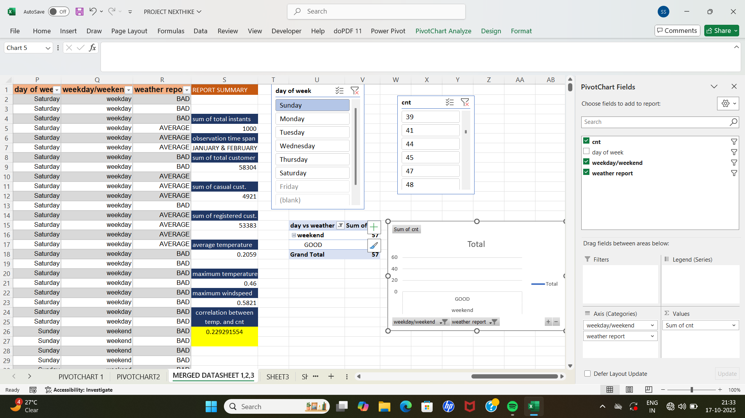

**5.Finally I did some analysis (given below) with the help of pivot table made from given data :**

**i.chart for hour vs count of customer**

**ii.chart for temperature vs count of customer**

**iii.chart and slicer for day,count and weather type**

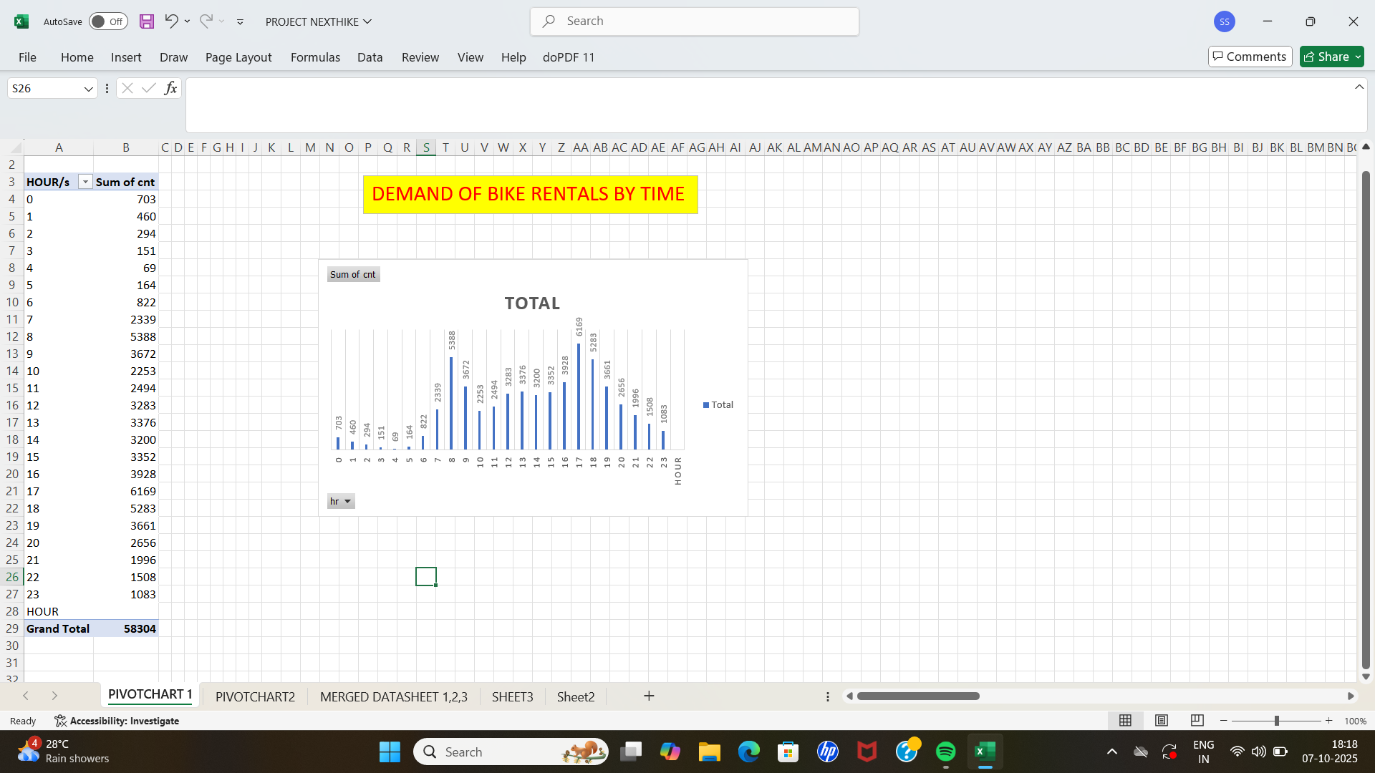

*Chart for hour vs total customer count*

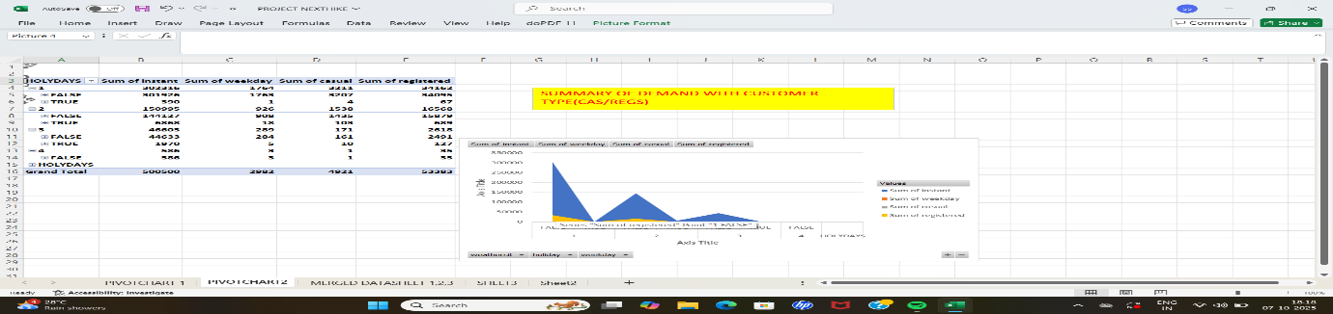

CHART FOR DEMAND OF BIKES FOR CASUAL AND REGISTERED CUSTOMER TYPE WITH HOLYDAYS AND NON HOLYDAYS



5.After performing all the analysis on the given data it can be concluded that

i. the demand of bike sharing is high at 8:00 of morning and 5:00 of afternoon.

ii.The correlation value 0.2292.. between temperature and customer count indicates that they have linear regression as the value is positive which means the demand of bike renting increase with the increase of temperature but as the value is close zero it suggests that the strength of the linear association is low.

iii.also people like to share bike when the weather is good or the humidity is low than the other weather conditions.

**THANK YOU!**